README FILE

OVERVIEW:

Live streaming is the streaming of video or audio in real time or near real time. While often referred to simply as streaming, the real time nature of live streaming differentiates it from other forms of streamed media, such as vlogs in youtube.
This project implements a client-server architecture for live video streaming over a network. The client receives video and audio streams,.

How does live streaming works ?

Live streaming is the process of capturing and distributing video or audio in real time over the internet. Here's how it works:
Capture: A camera, microphone, or other recording device captures the content
Compress and encode: The raw data is compressed to remove redundant information, and then encoded into a digital format
Segment: The data is segmented to avoid sending it all at once, which prevents bottlenecks and saves bandwidth
Receive and decode: The user receives the data and a media player decompresses, decodes, and converts it back into video and audio
The goal of live streaming is for viewers to see and hear what the live streamer is recording with as little delay as possible, ideally in real-time.

Live Streaming Process
- Connection Establishment:
- The server awaits input for client IPs and accepts connections.
- Clients specify their IP addresses to the server, which stores these for sending video ,audio.
- Frame Capture and Transmission:
- The server continuously captures frames from the camera and encodes them.
- It sends the encoded frame data to all connected clients via UDP.
- Receiving and Displaying Frames:

- Clients listen for incoming data on the specified UDP port.
- Upon receiving the data, they decode the bytes back into an image format and display it in real-time.
- Real-time Performance:
- The use of threads allows for simultaneous handling of client connections and video streaming,audio, enabling smooth performance.

PRE-REQUISITES:

Libraries (python libraries):-
- opencv-python: For video handling and display.
- numpy: For numerical operations.
- pyaudio: For audio handling.
- socket: Standard library for network communication.
- threading: For managing and handling threads .
Installation of libraries:-
pip install opencv-python numpy pyaudio
USAGE:

Server Setup
- Run the server code on a machine that will act as the streaming server.
- Make sure to set the correct IP address and port.

Client Setup
- Clone or download this repository.
- Modify the SERVER_IP and SERVER_PORT variables in the client code to match the server's IP address and port.
- Run the client code.
FEATURES:
- Real-time video streaming using OpenCV.
- Real-time audio playback using PyAudio.

1.SERVER INTERFACE
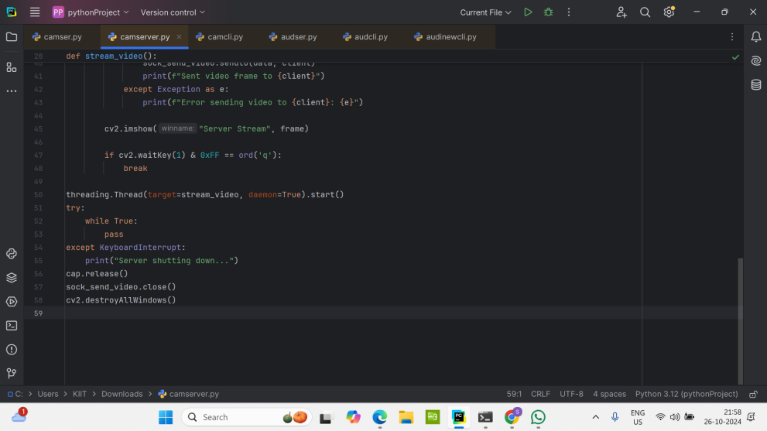

2.CLIENT INTERFACE
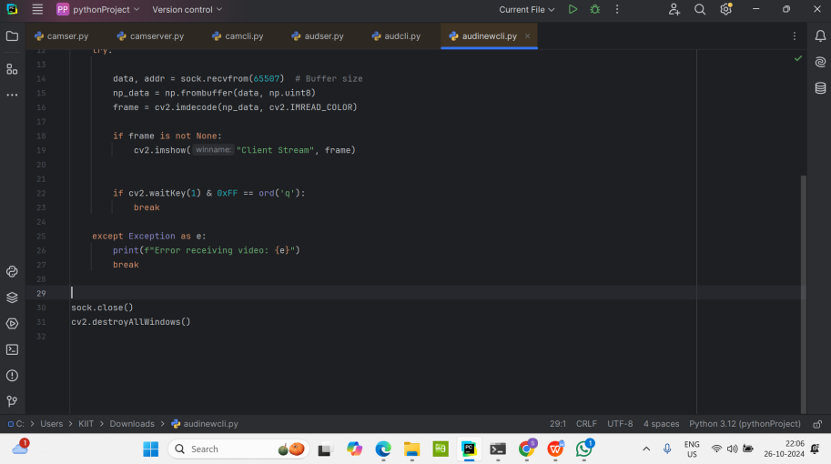

3.STARTING THE SERVER
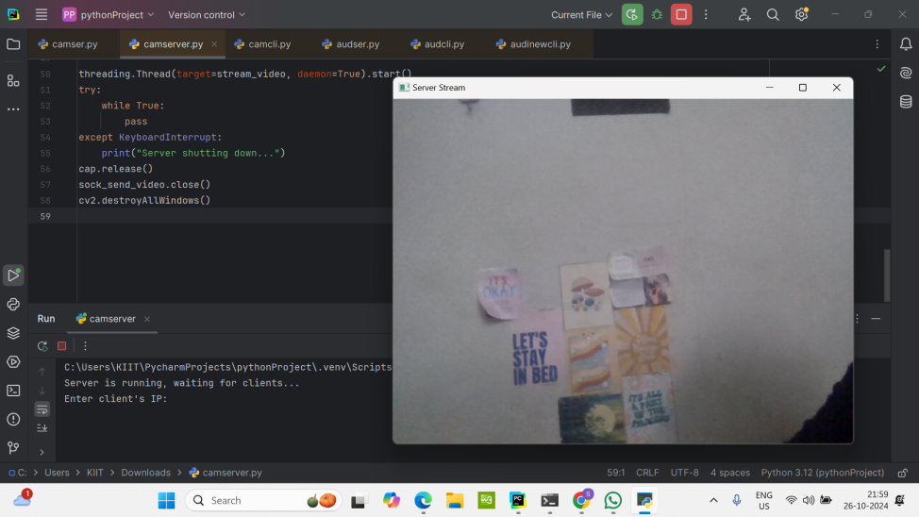
- ENTERING IP ADDRESS
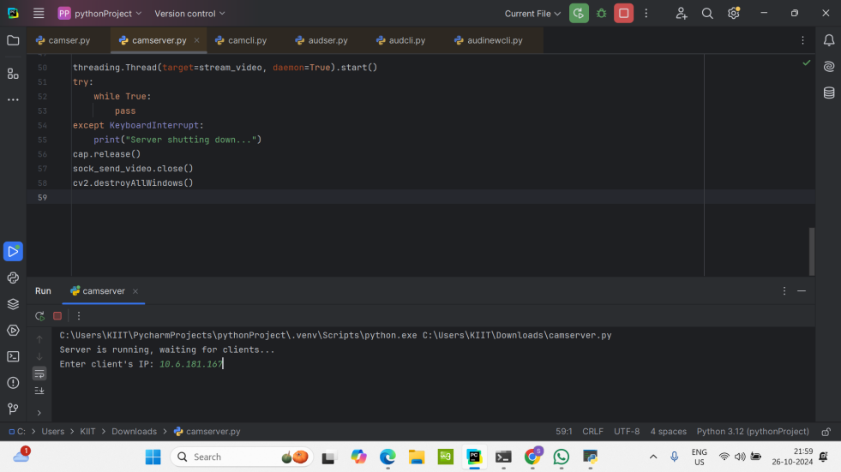
- CAMERA TURNS ON
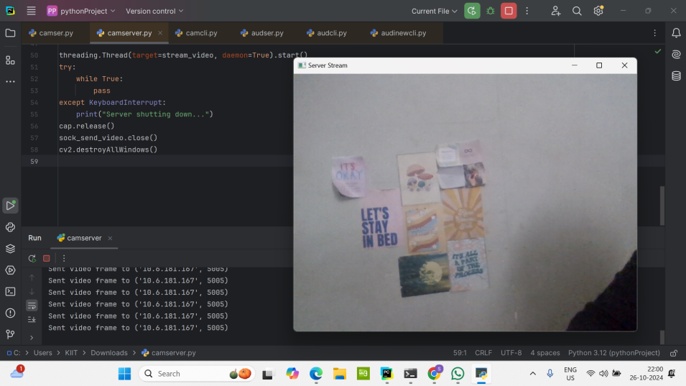
- CLIENT RECEIVES VIDEO
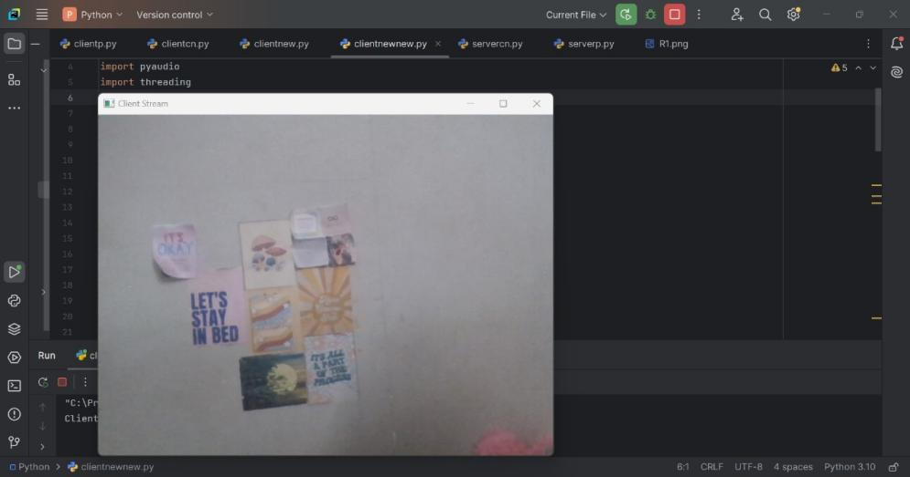
7.SERVER CLOSING
